Grade 8: Module 1: Unit 2: Lesson 7
Mid-Unit Assessment: Analyzing an Informational Text about a Refugee Experience

Long-Term Targets Addressed (Based on NYSP12 ELA CCLS)
I can cite text-based evidence that provides the strongest support for an analysis of literary text. (RI.8.1)
I can objectively summarize informational text. (RI.8.2)
I can analyze the connections and distinctions between individuals, ideas, or events in a text. (RI.8.3)
I can determine the meaning of words and phrases in text (figurative, connotative, and technical meanings). (RI.8.4)
I can use a variety of strategies to determine the meaning of unknown words or phrases. (L.8.4)
I can use evidence from informational texts to support analysis, reflection, and research. (W.8.9)
Supporting Learning Targets | Ongoing Assessment
- I can identify the strongest evidence in the speech by Til Gurung that helps me explain why refugees leave their home.  - I can identify the strongest evidence in the speech by Til Gurung that helps me explain challenges refugees face in their new country.  - I can determine the meaning of unfamiliar words based on context clues.  - I can cite evidence from the text to support analysis of an informational text. | - Mid-Unit 2 Assessment: Analyzing an Informational Text about a Refugee Experience (RI.8.1, RI.8.2, RI.8.3, RI.8.4a, L.8.4, and W.8.9)

Agenda | Teaching Notes
- Opening  - Review Learning Targets (2 minutes)  - Work Time  - Mid-Unit Assessment: Analyzing an Informational Text about a Refugee Experience (40 minutes)  - Closing and Assessment  - Debrief (3 minutes)  - Homework  - Complete a first read of pages 196-212. Take notes (in your journal) using the Structured Notes graphic organizer. | - During today’s assessment, students independently read an unfamiliar informational text about a refugee experience and answer literal and inferential text-dependent questions, as well as questions that assess students’ ability to determine word meaning based on context clues (L.8.4). Students also answer three constructed-response questions that require evidence from the text to support their answers. The last one is similar to the QuickWrites with which student are already familiar (W.8.9).  - Consider which students might need access to the separate glossary of Vocabulary Words from Assigned Reading to support them as they read independently. The glossary can be provided during an additional support class in advance, with time to pre-teach the words, or modified to be used by students independently (see supporting materials).  - Consider using the NYS 2-point rubric to assess students’ short constructed responses on this assessment. See Unit 1, Lesson 5 supporting materials.  - Post: Learning targets.

Lesson Vocabulary | Materials
Do not preview vocabulary for today’s assessment. | - Til Gurung’s speech from the Refugee Transitions’ “World of Difference Benefit Luncheon” (one per student)(for Mid-Unit Assessment)  - Mid-Unit 2 Assessment: Analyzing an Informational Text about a Refugee Experience (one per student)  - Mid-Unit 2 Assessment: Analyzing an Informational Text about a Refugee Experience (Answers and Sample Responses for Teacher Reference)  Optional Materials  - Extension Questions  - Extension Questions (Answers for Teacher Reference)  - Vocabulary Words from Assigned Reading  - Optional: NYS 2-point rubric (from Unit 1, Lesson 5; see Teaching Notes above)

Opening | Meeting Students’ Needs
A. Review Learning Targets (2 minutes)
- Read aloud the first two learning targets to students.
- Remind students that these learning targets should be familiar to them since they have been practicing these skills in the past several lessons.

Work Time | Meeting Students’ Needs
A. Mid-Unit Assessment: Analyzing an Informational Text about a Refugee Experience (40 minutes)  - Remind students that they have been reading informational texts on different refugee experiences. They have been collecting details from each text to help them understand why refugees leave home, the challenges they face in their new home, and some common themes among different refugee experiences. Share with students that they will show that they know how to do this on their own in this assessment.  - Arrange student seating to allow for an assessment-conducive arrangement where students independently think, read, and write. Encourage students by telling them that they have been working very hard at reading closely and today you want them to show what they have learned about word choice and tone in informational and fiction text.  - Distribute Til Gurung’s speech from the Refugee Transitions’ “World of Difference Benefit Luncheon” and the Mid-Unit 2 Assessment: Analyzing an Informational Text about a Refugee Experience. Read aloud through the directions.  - Address any clarifying questions. Invite students to begin. Circulate to observe but not support; this is students’ opportunity to independently apply the skills they have been learning.  - If students finish early, encourage them to complete the extension question for extra credit.  - Collect the assessment. | - On-demand assessments give the teacher valuable information about skills that students have mastered or those that still need to be developed.  - ELLs and other students may benefit from extended time, a bilingual glossary or dictionary, and a separate testing location.

Closing and Assessment | Meeting Students’ Needs
A. Debrief (3 minutes)
- Talk with students about the work they have done in this first unit, reading closely in the novel and with challenging informational text. Remind them that they are getting better at collecting details and evidence from texts.
Homework | Meeting Students’ Needs
- Complete a first read of pages 196–212. Take notes (in your journal) using the Structured Notes graphic organizer. Focus on the strongest evidence that reveals how Ha is being turned “inside out” (the challenges Ha faces and her dynamic character), plus vocabulary that helps you understand her challenges and responses. | - Consider which students might need access to the Additional Words from the Assigned Reading in the Vocabulary Guide (see supporting materials).  - Some students may benefit from a separate session in which they work on the Structured Notes with teacher support.

Grade 8: Module 1: Unit 2: Lesson 7
Supporting Materials
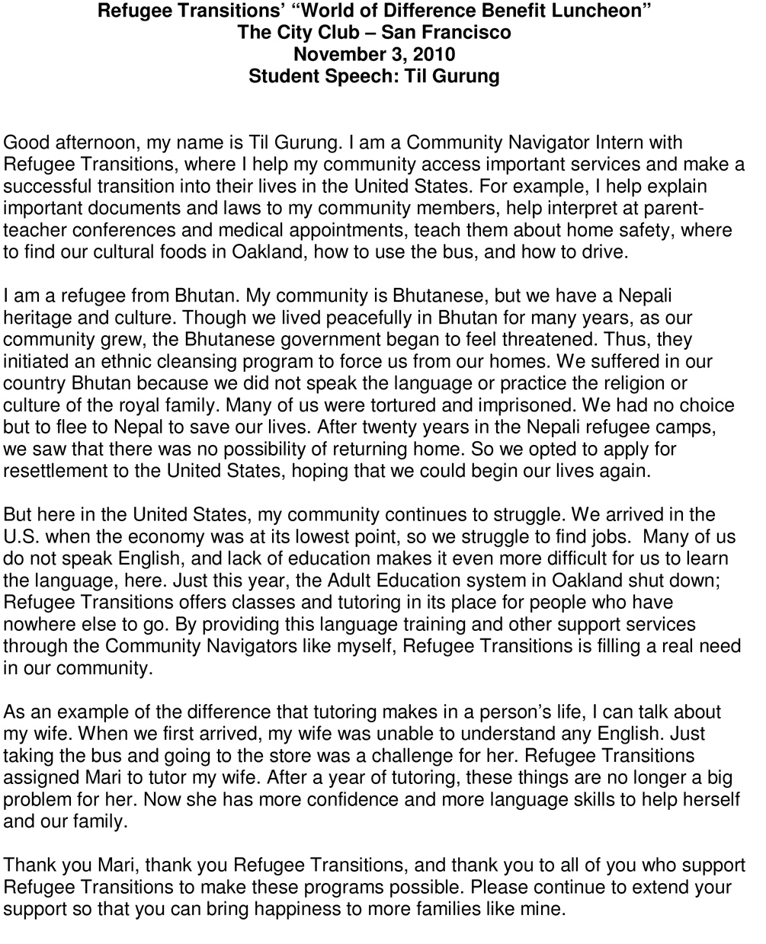

Used by permission from Refugee Transitions.

Name:
Date:

Directions:
Read the speech by Til Gurung once for gist.
Read the questions below and think about them.
Reread the text with the questions in mind. Look for the strongest evidence.
Write your answers, using specific evidence from the text to support your thinking.

- In the chart below, identify what Gurung’s life was like before and after arriving in the United States, using the strongest evidence from the text.

 | Summary Statement | Strongest evidence (at least two quotes from the text)
Before

 | Summary Statement | Strongest evidence (at least two quotes from the text)
After

- Why does Gurung help refugees transition to life in the United States? Cite two details from the text to support your answer.

- Part 1:
Based on context clues, what do you think the phrase ethnic cleansing might mean?

Part 2: Circle the sentence from the speech that best helped you figure out the meaning of the phrase ethnic cleansing.
a. “Though we lived peacefully in Bhutan for many years, as our community grew, the Bhutanese government began to feel threatened.”
b. “Many of us were tortured and imprisoned.”
c. “We had no choice but to flee to Nepal to save our lives.”
d. “After twenty years in the Nepali refugee camps, we saw that there was no possibility of returning home.”

4. Based on the entire speech, which of the following excerpts best reflects the author’s central idea? Circle your answer.

a. “I help explain important documents and laws to my community members, help interpret at parent teacher conferences and medical appointments, teach them about home safety, where to find our cultural foods in Oakland, how to use the bus, and how to drive.”
b. “After twenty years in the Nepali refugee camps, we saw that there was no possibility of returning home.”
c. “But here in the United States, my community continues to struggle.”
d. “By providing this language training and other support services through the Community Navigators like myself, Refugee Transitions is filling a real need in our community.”

5. QuickWrite: Based on the text, what are some of the problems refugees will have if Refugee Transitions loses funding or goes out of business?

Your QuickWrite should meet the following criteria:
- Answer the prompt completely
- Provide relevant and complete evidence
- Paragraph includes the following:
* A focus statement
* At least three pieces of specific evidence from the text
* For each piece of evidence, an analysis or explanation: What does this evidence mean?
* A concluding sentence

It is important that you select the strongest evidence that you have
(rather than all of the evidence that you have) for the paragraph.

Write your answer on the next page.

Quick Write Answer:

Review: In our last lesson, you worked with “sentence strips” and “quote cards” to identify evidence from the article on the Bosnian teens that related to the information from “Refugees: Who, Where, Why.” The three claims are listed again for you below.

Challenge: Read each of the claims from “Refugees: Who, Where, Why.” Below each claim, identify the strongest evidence from Til Gurung’s speech that supports the claim. Explain your thinking.

- “Today, more than 14 million men, women, and children have been forced to flee their homes, towns, and countries because they are afraid to stay.”

- “Some refugees cannot return home, nor can they stay in their country of asylum. They must resettle in a new country.”

- “Perceptions of unfairness, such as unequal treatment or denial of rights based on race, religion, economic status, or political thought, instigate war; so does unequal access to land, food, water, and other necessary resources.”

Directions:
Read the speech by Til Gurung once for gist.
Read the questions below and think about them.
Reread the text with the questions in mind. Look for the strongest evidence.
Write your answers, using specific evidence from the text to support your thinking.

1. In the chart below, identify what Gurung’s life was like before and after arriving in the United States, using the strongest evidence from the text.

 | Summary Statement | Strongest evidence (at least two quotes from the text)
Before | His life was in danger in Bhutan because of the government, so he went to live in the refugee camps in Nepal. | “Thus, they [the government]  initiated an ethnic cleansing program to force us from our homes.”  “We suffered in our country Bhutan because we did not speak the language or practice the religion or culture of the royal family. Many of us were tortured and imprisoned.”

 | Summary Statement | Strongest evidence (at least two quotes from the text)
After | He works for an organization that helps refugees learn to be successful in the U.S. | “I am a Community Navigator Intern with Refugee Transitions, where I help my community access important services and make a successful transition into their lives in the United States.”  “I help explain  important documents and laws to my community members, help interpret at parent teacher  conferences and medical appointments, teach them about home safety, where to find our cultural foods in Oakland, how to use the bus, and how to drive.”

2. Why does Gurung help refugees transition to life in the United States? Cite two details from the text to support your answer.

Gurung helps refugees transition to life in the U.S. because it is important for refugees to have support if they are going to make a successful life. He says, “Many of us do not speak English, and lack of education makes it even more difficult for us to learn the language here.” He feels that he is helping to fill “a real need in our community” by teaching English and helping refugees with all the things he helps them with, such as legal documents, home safety, and where to find cultural foods.

3. Part 1:
Based on context clues, what do you think the phrase ethnic cleansing might mean?

Ethnic cleansing means a program of imprisoning or torturing people based on the ethnic group they belong to, like the Nepali living in Bhutan.

Part 2: Circle the sentence from the speech that best helped you figure out the meaning of the phrase ethnic cleansing?
a. “Though we lived peacefully in Bhutan for many years, as our community grew, the Bhutanese government began to feel threatened.”
b. “Many of us were tortured and imprisoned.”
c. “We had no choice but to flee to Nepal to save our lives.”
d. “After twenty years in the Nepali refugee camps, we saw that there was no possibility of returning
home.”

4. Based on the entire speech, which of the following excerpts best reflects the author’s central idea? Circle your answer.

a. “I help explain important documents and laws to my community members, help interpret at parent teacher conferences and medical appointments, teach them about home safety, where to find our cultural foods in Oakland, how to use the bus, and how to drive.”
b. “After twenty years in the Nepali refugee camps, we saw that there was no possibility of returning home.”
c. “But here in the United States, my community continues to struggle.”
d. “By providing this language training and other support services through the Community Navigators like myself, Refugee Transitions is filling a real need in our community.”

5. QuickWrite: Based on the text, what are some of the problems refugees will have if Refugee Transitions loses funding or goes out of business?

If Refugee Transitions loses funding or goes out of business, it will have negative consequences for many refugees. Til Gurung, who works for Refugee Transitions, helps refugees with important things that help refugees live a normal life. For example, if Refugee Transitions closes, they might not have the help they need to read “important legal documents” like a will if someone dies, or something from their landlord or bank. This could mean they could get sick or lose their home. Refugees might also be more isolated if they don’t speak English. Learning the English is important to living a normal life in America. He said that “just taking the bus and going to the store was a challenge” for his wife until she learned English. It’s hard to feel connected to a community if you can’t understand people or get around. If this center closes, refugees might not be able to get jobs that pay as much if they don’t have “classes and tutoring” that help them get ahead in life. If Refugee Transitions loses its funding or goes out of business, refugees will have to struggle on their own and it will be hard for them to get used to life in America.

- “Today, more than 14 million men, women, and children have been forced to flee their homes, towns, and countries because they are afraid to stay.”
Til Gurung says the Nepali in Bhutan had no choice but to leave their homes because they feared for their safety, which illustrates the idea that people are forced to flee their homes and countries because they are afraid to stay.

- “Some refugees cannot return home, nor can they stay in their country of asylum. They must resettle in a new country.”
Gurung explains that when things got bad in Bhutan, his people fled to Nepal. After 20 years in refugee camps, they knew they would never get to return home, so they went to the U.S. to start a new life, confirming this idea that some refugees can’t return home or stay in their country of asylum.

- “Perceptions of unfairness, such as unequal treatment or denial of rights based on race, religion, economic status, or political thought, instigate war; so does unequal access to land, food, water, and other necessary resources.”

Gurung explains that the Nepali living in Bhutan did not practice the same religion or have the same culture as the Bhutanese, so they were treated differently—they were put in jail, tortured, and killed.

Grade 8: Module 1: Unit 2: Lesson 7
Optional MAterials

Vocabulary Words from Assigned Reading

Word | Page | Definition
echoes (v) | 196 | repeats
strained (adj) | 203 | tense
hoists (v) | 209 | lifts

